CONTINGENCY PLAN
TEMPLATE

RISK(S)

(Add National Society logo)

(include a map of the geographical area if relevant)

[The text under each section is to guide a National Society and should be removed and/or replaced by National Society specific information. To access further tools click on icons and/or links provided in the template.]

Risk(s) considered: Risks/hazards considered Period covered by the plan: Validity period
Population in the area of intervention: Total population Name/contact of responsible:
Geographical area covered by the plan: Date of validation:

Table of contents

Introduction 3
Context description 3
National Disaster Risk Management framework 3
National Society mandate and role 3
Risk Analysis 4
Hazards and threats 4
Risk matrix 4
Option 1: risk matrix using pre-established definitions 4
Option 2: compare likelihood and impact of identified hazards/threats 6
Prioritize hazards to plan for 6
Scenario setting 7
Elements to consider in scenario setting 7
Define vulnerabilities and capacities 7
Scenario assumptions 8
Scenario triggers and thresholds 8
Define your scenario 9
Response strategy and operational plan 11
National Society current response capacities 11
Response strategy 12
Objective of the plan 12
Intervention sectors 12
National Society operational response plan 14
Resources Management 16
Response plan budget 16
Human resources management 17
Finance management 17
Supply chain management 17
Response Management Arrangements 17
Management structure 17
Overall management 17
Emergency Operation Centre 18
Activation of the plan and communication 18
Activation of the plan 18
Communication 19
Coordination 19
Internal – within Red Cross Red Crescent Movement 19
External – outside Red Cross Red Crescent Movement 19
Security 20
Reporting and monitoring 20
Validating, sharing and reviewing 20
ANNEXES 22
Contact list 22
Standard Operating Procedures 22

Introduction
This Contingency planning template document which is ready to be filled in, is to be used with the IFRC How to conduct a contingency plan process accompanying support document which will guide you through the five phases of the contingency planning (CP) process. Prior to starting filling in this template document, your National Society should proceed with the first phase of the contingency planning process explained in How to conduct a contingency plan process: Preparation phase. In this phase, the option of a Movement Contingency Plan is also considered and adopted if relevant (SMCC toolkit).
This introductory section of your National Society contingency plan refers to STEP 1 of the Analysis phase of the same document. If a National Society has gone through a Preparedness for Effective Response (PER), Forecast based Financing (FbF) or Business Continuity (BCP) processes, information on the risk analysis, historical impact, prioritized risks, exposure, vulnerability analysis, impact curves and triggers will be already available. It is suggested to review this information and use it to simplify analysis phase. The FbF Early Action Protocol (EAP), the Business Continuity Plan could be part of the National Society contingency plan and therefore documents need to be considered side by side to avoid contradictions or duplications. At another level, the CP result could be an integrated result of the PER process.

Context description
Brief geographical, economic, political, social and security country description. List the main risks related to all hazards (including public health emergencies, technological hazards, etc.)
Every point mentioned in the context description should be useful for your risk analysis. This section needs to remain brief, clear and related to your specific response context. This is not hazard-specific but should cover the main country risks. Country context analysis might already exist in your country. Look for it, and/or work with a university and/or institutions who already have the information (such as UNOCHA – Humanitarian Response plan or World Factbook).

National Disaster Risk Management framework
Give an overview of the government national and local structures and mechanisms in charge of disaster management (preparedness and response). Key actors include, for instance, the National Disaster Management Office, Civil Protection, Ministry of Health.
List the policies, strategies and plans the government has to prepare for and respond to various types of disasters. Explain specific coordination and funding mechanisms (for example FbA by DREF) put in place by the National Society. Define what the position of the National Society is as part of national and local Emergency Operation Centres (EOC).
Explain: Is the National Society’s role in times of disasters, epidemics or during complex emergencies reflected in government plans?
Use graphs and visuals to position the National Society in its National Disaster Management Framework. For further guidance, refer to: Disaster Law database, IDRL guidelines-introduction

National Society mandate and role
Describe National Society vision/mission, strategic priorities or development plan and main structures in place to achieve its mandate and support its auxiliary role.
What are the National Society main sectors of intervention in response time (considering in addition structures managed by the National Society such as health facilities)? Specify: What is the National Society’s role in times of imminent crisis, disasters, epidemics or during complex emergencies?
In this section, it is important to ensure your National Society’s capacities and the resources identified are in accordance with your mandate and role. Refer to the table on National Society sectors of intervention in the section Response strategy and operational plan.
If your National Society has started strengthening its Preparedness for Effective Response (PER) mechanism, key documents about the organization’s role and mandate might have already been analysed. To find further guidance, refer to: Auxiliary role, IFRC Strategy 2030, Resolution “Time to act: Tackling epidemics and pandemics together” adopted at the 33rd International Conference

Risk Analysis
Refer to STEPS 2 and 3 of the analysis phase of the IFRC How to conduct a contingency planning process document.

Hazards and threats
The hazards and threats assessment considers the range of potential hazards within the operating environment of the National Society. This includes natural and man-made hazards, of various scopes and magnitude, against a continuum of recurring and non-recurring onsets. You can start with considering the impacts of hazards in the last 10 years. Then the assessment also considers potential hazards with no history along with complex and compound events that may involve the intersection of two or more hazards. If your National Society has undertaken this hazards and threats analysis process to establish your National Society Business Continuity Plan (BCP), your Early Action Protocol, or your PER process, you could also use a similar approach and/or the already existing results from such an analysis. Information about key hazards/threats, vulnerability and capacity is usually available from national agencies, research institutions and humanitarian organizations. You can find further information on international indexes as for instance: INFORM, Global Health Security Index, International Health Regulations Monitoring & Evaluation, Prevent Epidemics Readiness Score

Within your team and with other participants in the process, list the hazards to consider in your contingency plan. Considering all hazards, fill up the following table. Consult government and UN country teams’ plans to ascertain if any particular role has been attributed to your National Society. Consider information available on past events, how often has it occurred, severity of the impact, as well as new or re-emerging high-threat infectious diseases and hazards on the increase due to climate change, political instability, resource availability or urbanization for instance. Do not forget cross-border events which could require coordination with neighbouring countries.

 | Where | WHAT | When
Hazard 1 | Location, areas, limits | Describe the hazard including root causes, warning signs, reactions, existing mitigation measures | When is it most likely to happen (e.g. is it a seasonal hazard linked to the dry/wet season)?
Hazard 2

Risk matrix
The risk matrix helps assess the likelihood that an event will happen (probability and/or frequency) and its impact (on your population, infrastructure, systems). Consider your population, infrastructures, environment, economy and society. There are two templates you can use to assess likelihood and impact, one uses pre-established definitions and the second compares identified hazards and threats against one another. Option 2 might be easier to use with limited information.
Respond to the following questions for each hazard:
- In the likelihood column => what are the indicators (elements) which could signify the hazard/event will occur in the next Y weeks or months (refer to likelihood table definition) ?
- In the impact/exposure column => How might the situation develop over the next Y weeks or months (when do you think it might start and how long do you think it might last)? (use the same timeline as the previous question)

Option 1: risk matrix using pre-established definitions
Based on the hazards list established earlier, use the following table to classify your hazards/threats, consider occurrence, likely impacts/damages on population, infrastructure, environment, economy and society. The definitions below can help assess the likelihood and impact of each hazard/threat. They might need to be adapted to your country/location situation (area of intervention). To define numbers start with the full picture (i.e. total population) and define overall number as minor (few deaths), moderate (several deaths), or severe (hundreds of deaths). Do the same with infrastructure, considering the overall number as 100 per cent, so negligible could be below two per cent and no vital infrastructure impacted (hospital, schools, essential access roads, power grid, airports/ports).
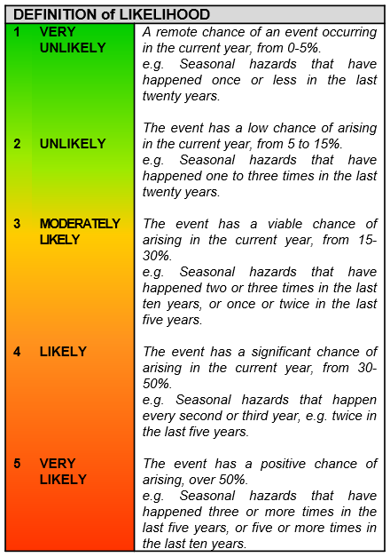 | 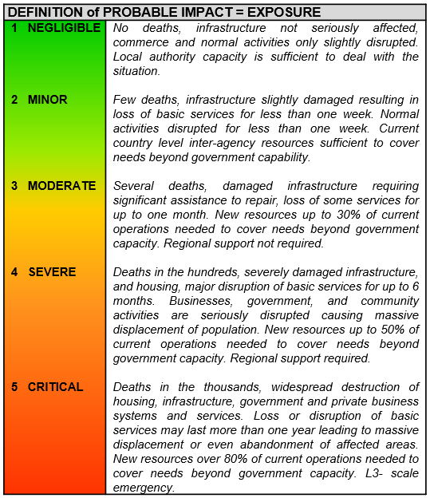

Classify your hazards/threats
Seriousness (Risk) = Impact X Likelihood | Low (1-7) | Moderate (8-14) | High (15-25)
Characteristics | Threats of a low magnitude with damages in a limited area and low potential of causing damages to people or infrastructure. | Threats with damages in geographical zones, which could affect vital networks and services, with the possibility of short-term recovery using local resources and capacity. | Threats with a large potential to cause multiple damages to infrastructure and services in exposed communities. Threats with severe damages which require external attention and resources to manage the emergency situation.

To evaluate the risk, multiply the impact by the likelihood.
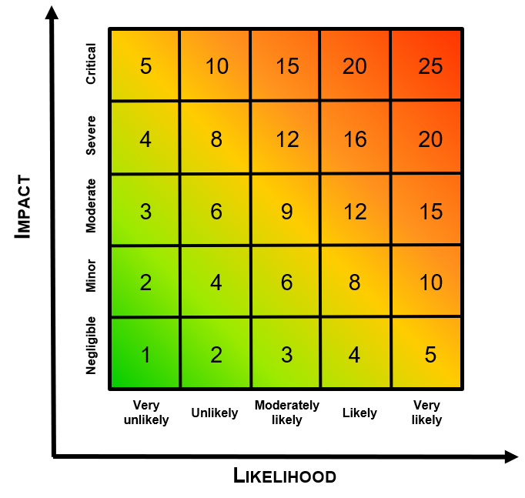

Option 2: compare likelihood and impact of identified hazards/threats
Based on the hazards/threats list established earlier, use the following table to classify your hazards/threats based on their estimated importance compared to each other. The hazards/threats below are given as examples.

Impact
Critical |  |  |  | Internal displacement | Drought
Severe |  |  |  | River burst floods | Road accidents
Moder-ate |  |  | Armyworm | Flash floods  Refugees | Epidemics/ infestation
Minor |  |  | Landslides  Pollution | Urban fires  Forest fires
Negligi-ble | Extreme weather
 | Very unlikely | Unlikely | Possible | Likely | Very likely
Likelihood

Prioritized hazards
High:  - Drought  - Epidemics  - Internal displacement  - River burst floods  - Road accidents  - Infestation | Medium:  - Armyworm  - Flash floods  - Forest fires  - Refugees  - Urban fires  - Waste management | Low:  - Backwash floods  - Extreme weather  - Landslides  - Pollution

Prioritize hazards to plan for
Going back to the two questions to establish the risk matrix, you can now prioritize hazards your National Society should plan for, in the table below. The risk matrix above provides information related to likelihood, impact and risk level. Colour code related to risk levels can be used to visualize the analysis.
Based on the National Society role in responding to emergencies, its capacity and the services it offers to the population, which risks does the National Society need to consider? List the hazards starting from the one which will have the highest risk level down to the one with the lower risk level. This table could be read again in the light of the work to be done under the following section (Scenario setting – Define vulnerabilities and capacities) which will detail the vulnerabilities and exposure to a specific hazard.
 | Likelihood | Impact | Risk level | Role and capacity of National Society | Comments
Hazard 1 | Number 1 to 5 | Number 1 to 5 | Number 1 to 25  (likelihood x impact)
Hazard 2
Or combination of hazards

Hazards/threats ranked as Low will not be further elaborated in your contingency plan. Epidemics that are ranked 10 or higher should be addressed as a priority if your National Society’s role includes responding to epidemics and pandemics. For further information related to risk assessment for epidemics, see World Health Organization. Communicable disease risk assessment: protocol for humanitarian emergencies. Geneva: WHO; 2007. Risks that are potentially very likely but with lower impact can be prioritized depending on the role of your National Society, available resources and context. Only keep the list of risks your National Society will plan for in the core body of your CP. Put all definitions and analyses into annexes.
Particular attention should be paid to geographical areas impacted by more than one hazard. This could help identify people who might be most exposed and at risk to define response options addressing several hazards at once. It will also optimize the use of the available resources (always too limited when the country faces several hazards). If you have risk maps you can add them in this section or in an annex.

Scenario setting

Elements to consider in scenario setting

Define vulnerabilities and capacities
The risk of disaster is linked to a population’s vulnerability to particular hazards/threats and related dimensions compared to its capacity to manage it. Further tools and explanation on capacities and vulnerabilities analysis could be find on Enhanced Vulnerability and Capacity Assessment website.
This section helps deepen the risk analysis in your country/zone of intervention.
- What is the vulnerability of the population, infrastructure and economy to each priority hazard?
- What are the community, civil society members, local and national authority’s capacities to prepare for, respond to and recover from the impact of the hazard(s) the population is exposed to?
- Identify the humanitarian context in the area(s) of intervention. What are the capacities and gaps (to be included in vulnerabilities) of the disaster response?
Be as precise as possible with numbers and indicators, as this will help in defining your thresholds in the scenario. Here we are speaking about levels where you will consider moving from one scenario setting to another. To summarize the information you can use the table below:
 | Vulnerabilities | Capacities | Examples of indicators
Physical / material/ economic  What productive resources, skills, natural capital exist? |  |  | - Quality of the means of communication  - Presence of public infrastructure and shelters  - Presence/accessibility to evacuation routes in the event of a disaster  - Quality of dwelling construction  - Situation of people, infrastructure, housing, production capacities and other tangible human assets located in hazard-prone areas.  - Family income level  - Unemployment rates  - Levels of extreme poverty
Social / human / organizational  What are the relations and organization among people? |  |  | Organizational:  - Existence of early warning systems  - Existence of response plans, systems and skilled teams  - Presence of development projects, NGOs  - Existence and functionality of community organizations, social groups, etc.  - Potential impact on human resources  Social / human:  - Level of community access to basic services such as potable water, sanitation and health services  - Level of social cohesion toward the presence of different ethnic groups, family disintegration, etc.  - Access to education  - Existence of most vulnerable groups: disabled, children, single mothers and elderly – access to services?
Institutional  What are the humanitarian capacities and gaps in the area of intervention? |  |  | - Presence of assistance/relief entities such as local institutions (government, local community actors.), fire department, police, civil defence, etc.  - Human resources dedicated to disaster response  - Financial resources dedicated to preparedness and disaster response  - Awareness and commitment of local authorities to disaster reduction  - Legislation, plans and instructions for local/national disaster management  - Access to vulnerable populations in disaster situations  - Readiness and quality of mechanisms for receiving external and international assistance
Under physical/material include all information related to infrastructure. Depending on your context, it might be good to have this table split into detailing:
- The communities and/or region/city/department capacities which balance their vulnerabilities (and therefore reduce the impact of the disaster) and on which the National Society will have to build its response (in the operational plan) to ensure that the support provided by the Red Cross Red Crescent comes to complement/reinforce the existing capacities at community level and not overwhelm them.
- The “stakeholders analysis” table. Using similar headings as in the cash in emergency toolkit stakeholders analysis could help your National Society to do this exercise.
- For National Societies with a developed EAP this section will correspond to the exposed elements and their vulnerability factors, where an analysis of exposure is presented to determine who and what is located in the area where the hazard might occur. This will help to determine who and what is likely to be impacted.
This table serves the analysis: keep only key data in the main body of the contingency plan document. Make your plan visual, using illustrations, graphs, tables, etc.

Scenario assumptions
The description of the situation and exposure lead to assumptions about future scenarios. Assumptions are the directions a hazard/threat (or a combination) can take (e.g. increase, decrease). The following categories can be used to define assumptions. The following examples can be adapted to suit your situation.
Assumption categories | Examples of Assumptions
Evolution of current variables | Increased flooding, severe aftershocks, spread of epidemics, escalating conflict, economic collapse, no significant change in situation
Evolution of possible future variables | Increased influx of refugees, political stalemate, eruption of conflict over resources, successful international intervention
Evolution of the population’s capacity to cope with the crisis | Decrease of purchasing power, loss of assets, decreased access to resources, lack of access to humanitarian aid
Evolution of ability of national/international actors to respond to needs | Roads and bridges washed out, conflict preventing access to affected areas, failed negotiation with insurgents for access to communities
For further information on defining assumptions follow the link here: ACAPS - Summary Brief on Scenario Development.

Scenario triggers and thresholds
Based on assumptions, your National Society will determine triggers and thresholds that will respectively indicate the different phases (alert, early actions, response…) and the magnitude of the event (moderate to critical). Using the results of the risk matrix, your National Society should define values for the different scenarios (most likely, worst case). The triggers and thresholds will guide the transition from the different scenarios. For National Societies with developed EAPs the trigger will have been already pre-agreed based on historical impact analysis, exposure analysis, vulnerability analysis and meteorological models. This information can be used to show what magnitudes of the event has caused disastrous humanitarian impacts in the past, helping the National Societies to define triggers (to move through the different phases and anticipate the degree of emergency).

As per example of values, for a flooding situation in a determined location thresholds could be:
- Below 500 targeted population = moderate – local response  - Between 500 to 5,000 targeted population = severe – HQ support  - Above 5,000 targeted population = critical – call for international support | IMPORTANT: This is just an example The figures should match the real situation in the location and your National Society capacities to respond.
The triggers in that flooding case could be many:
- Monsoon season is coming => review your contingency plan/actions.
- Meteorological agencies release a seasonal forecast for higher than normal monsoon activity => Identify higher risk areas, work with branches in those areas.
- Meteorological service issues an alert bulletin => start community early warning / early action (in coordination with local authorities) – such as alert, evacuation, etc.
- Rain gauges alert levels have been reached => needs assessments….
For outbreaks, your Ministry of Health can advise on alert/epidemic thresholds. National Societies in high-risk countries can identify triggers to activate immediate response actions. Ideally, these triggers should be part of the national response plan for epidemics. However, a National Society can also use its internal trigger system to advocate for immediate action among their partners, and act independently if appropriate to verify a potential outbreak. Amongst the triggers, it is important to consider verified outbreaks in neighbouring countries.
For weather-related hazards, triggers could be based on weather and climate forecasts (best source would be national/regional meteorological services) combined with potential estimate of impact (go back to your risk analysis to define the levels of best, most likely and worst case scenarios). In that type of scenario, the threshold is the degree of predicted loss and damage (human, livelihoods, infrastructure, environment, etc.), combined with the trigger - the degree of humanitarian impact of an extreme event that would initiate action. Forecasts should be analysed considering their type, reliability, lead times, and sources of data to allow the National Society to decide which one to use. Note that this information does not need to be analysed or calculated by the National Society, but can be obtained by working with hydro-meteorological services, research institutions, experts etc.
All your defined triggers and thresholds will serve to feed the scenario table below. They could also be reported in your Standard Operating Procedures (SOPs) (refer to template in annex). If your scenario triggers and thresholds are included in the scenario table and SOPs, this section can be removed from your CP.
Check if triggers and analysis already exist in your country/align with existing triggers (including other partners’ data). It might be easier to start setting the scene (scenario) before defining your triggers.

Define your scenario
For each scenario describe what happens and what damages and/or losses it causes, then which needs will appear in consequence of those damages/losses. There should be enough details to transition directly to the next section which describes the objectives of the plan. The scenario could consider a combination of hazards. It is proposed to consider best, most likely and worst case scenarios. However it could be enough to look only at the most likely and worst case scenario. Look at which scenarios have been developed by national/local authorities and institutions.
Example: Scenario: a medium intensity tropical cyclone affects such and such regions, causing this type of damage here, here and there. The National Society’ mandate in the National Disaster Management strategy is to provide support in the areas of such and such. The affected population will face lack of (e.g. potable water). Add expected number of people or households facing those needs (might be different depending on the type of needs).

Situations | Best | Most likely | Worst
Description of the event - Describe the crisis. Be short and succinct, but include threats, vulnerabilities and assumptions
Triggers/thresholds determining onset of crisis
Potential duration of crisis (or lead time)
Description
Geographical areas of concern
Underlying causes
Secondary risk in relation to the scenario
Casualty – Determine the numbers which will characterize your different scenarios
Death
Injury/illness
Missing
Affected Population – Determine the number of people affected?
Local
Foreign
Migrants
Potential impact on – Which level of impact will characterize your different scenario?
Housing
Properties
Access to food
Livelihood/business
Agriculture
Fisheries
Health infrastructures
Public infrastructures
Access to water
Operational constraints – What will be the operational constraints for each scenario?
Roads
Bridges
Communications
Power
Impacts on response capacities How far could hazards/threats impact National Society ability to respond?
Staff/volunteers availability
Infrastructures impacted
Damage on installations/material
Security matters
Others

Response strategy and operational plan
Refer to the development phase steps and actions of the IFRC How to conduct a contingency planning process document.

National Society current response capacities
Describe National Society capacities: physical (stock, fleet, warehousing, health facilities, ambulance service, blood bank, etc.), human resources (staff, volunteers), financial, information management, communication. Outline stock prepositioning strategy for the stock management aspects. Make sure your National Society response strengths and areas of improvement vis-à-vis your mandate are well identified.
The National Society Preparedness for Effective Response (PER) approach can help review the operational response capacity of your National Society. The illustration below provides an overview of all areas and components of the PER mechanism. On the left hand side you will find a subset of components which can be used to quickly review the operational capacity of the National Society. If the PER process is in progress, it can still provide a summary of which components are working well and which need improvement, highlighting some specific strengths and gaps. FbF projects have normally also a capacity strengthening component to get the National Society “FbF ready”. How this connects to PER and contingency planning is discussed in this guidance note.

Early action mechanisms  Emergency needs assessment  Continuity of operations during an emergency  Affected population selection  Emergency Operation Centre  National Society technical sectors:  - Community-based DP and DRR  - Evacuation  - Health in emergency  - First aid  - Water and sanitation  - Food security  - Livelihood security and safety nets  - Search and rescue  - Shelter, household items, settlements  - Management of dead bodies to facilitate their identification  - Restoring Family Links (RFL)  - Transition to recovery  - Chemical, biological, radiological and nuclear (CBRN) emergency preparedness  - Community-based health and first aid (CBHFA)  Logistics and transport  Finance and Human resources  IT and telecommunications  Information Management | 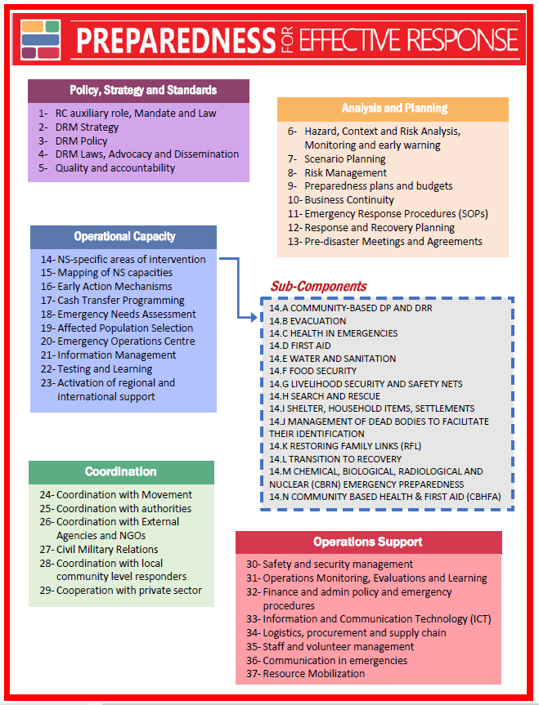

Response strategy

Objective of the plan
The objective: the National Society will support X number of households affected by the hazard 1 / 2…(or combination of hazards) in regions Y and Z, by providing this and that over a period of X months.
Ideally your National Society should first detail which scenario has been chosen to develop the operational plan (the most likely scenario most of the time). Detail here that the objective and plan will be adjusted based on the outcome of the emergency needs assessment once the hazard has hit.
NB: you can choose a small percentage of the total number of expected affected households and also select only a few of the expected affected regions. It should match the National Society capacities, not the impact of the disaster. Otherwise it will be unrealistic, it will not be achieved and it will lead to a great deal of frustration. If the plan is disseminated outside the Red Cross Red Crescent, it could lead to high expectations which will not be met by the National Society. Also limit the number of sectors of intervention to what the National Society can really manage. Here it is really important also to coordinate with other actors in the field and always target the sectors of intervention where the National Society will bring the best value.
You can define several objectives and sub-objectives but keep them limited to make sure they are realistic and achievable (maximum three to five).
If the National Society is undergoing and FbF process it will have already identified some the early actions to prevent or reduce impacts on the vulnerable population and start preparing for an effective response.

Intervention sectors
Here, the role of the National Society is key, including its capacity (e.g. number of branches/volunteers) but also the types of services and projects (e.g. ambulance service, health facilities, blood bank) it offers.
Define the main intervention sectors of the National Society with target numbers (as per objectives set above). Determine as well the cross-cutting issues. You can use a graph or table as it best suits you.
The areas of intervention below are given to guide you in identifying your areas of intervention. This needs to reflect your current intervention capacities to respond to the particular scenario identified in the analysis phase.

Sectors of intervention | Most likely scenario | Worst case scenario | Responsible
Early warning / Early Action
Community early warning | Detail capacity/resources used | idem
Volunteers’ mobilisation
EOC set-up
…. | For each sectors below identify early actions needed
First response
Search and rescue
First aid
Emergency evacuation
Emergency assessments
Emergency relief aid
Restoring family links
Health facilities
Health community centre
Hospitals
…
Shelter and household goods/Non-food items (NFIs)
Emergency shelter management (evacuation centre)
Emergency shelter support (tools, cash and vouchers assistance)
NFIs
Fuel for dwellings
Build back better technical support
Livelihood and basic needs
Short-term distribution
Long-term distribution
Development of productive assets
Supplementary/curative feeding, nutrition
Agriculture
Nutritional monitoring
Health
Treatment/case management
Community based environmental management, fogging, source reduction and larvicide, bed net distributions
Community-based surveillance, border screening, contact tracing, testing
Vaccination campaigns
Infection prevention and control
Psychosocial support (PSS)
Risk Communication and Community Engagement (RCCE)
Dead body management
Water, sanitation and hygiene
Distribution, storage, processing
Distribution of water and hygiene NFIs
Rehabilitation/development of alternative sources
Sanitation access and use
Disposal of garbage
Personal hygiene
Insect and rodent control

National Society operational response plan
What are the main activities your National Society will implement to achieve the objective(s)?

The sequencing is aiming to help your National Society not to forget any critical activity depending on timing. You can refer to the same technical sectors as the ones used to identify your capacities. Refer to the table of vulnerabilities and capacities and suggested list below. Do not forget your logistics, finance, human resources, Information Management and ICT support. NB: This operational plan should be developed for your most likely and worst case scenario as the response will be proportional to the intensity of the impact. If the National Society has an EAP for this same hazard it should make sure that the activities of the EAP are also described in the sequencing and that considerations are given to the resources that are committed to the implementation of the EAP (e.g. volunteers, staff, vehicles, etc.).
Your operational plan should be the product of the analysis of the following factors:  - Population needs (and capacities, as mentioned above)  - National Society capacities and expertise  - Intervention of other actors  - Operational constraints (access etc.) | A well prepared operational plan will serve your National Society to develop its Emergency Plan of Action for a specific scenario (feeding your resources mobilization needs). Further guidance is available on National Society guidance for EPoA.  This operational plan, when it is well developed, could also serve as the basis of your reporting system, from resources mobilization to final operation reporting.

Activity | Actions to be taken |  |  |  |  | Targets | Lead responsible
 | Early actions  (During warning) | First week  (24h – 72h to 1 week) | up to first month | 1 month to 3 months | Over 3 months
Structure and management
Activity 1 - Activity 2 - ….  List all activities to manage and allow decision making. | Timing and early actions depend on type of hazard | Action 1  Action 2  Detail actions to reach overall activity |  |  |  | Consolidated targets to be reached | Name and position of lead responsible
Operational planning and support (including subheadings for each technical sector and support unit)
Use headers and activities as per table above on National Society intervention sectors or use examples from: Emergency Plan of Action template-2019 |  |  |  |  |  |  | Branch X, Y, Z  National Society HQ, Department  ICRC – IFRC - PNS
Information and reporting
Resources mobilization
For more information, refer to
Resource Development Handbook

Surge capacity (national, regional and global, depending on the need)
How your National Society will mobilize surge capacity. Refer to IFRC Emergency Response Framework-2017

Movement coordination and humanitarian diplomacy
Principles and rules for Red Cross and Red Crescent humanitarian assistance

Resources Management

Response plan budget
Use the same headers as in your operational plan (complete the table as necessary), then per activities identified, list the resources you need to implement them. Depending on your National Society’s normal method of budget monitoring, you can also split some expenses by type. Include all needs (human resources, fleet, transportation, equipment, IT, material, stocks, storage, etc.). For National Societies with an approved EAP remember that contingency planning activities reflected in the EAP (that will be implemented under the early action phase) will be funded by the Forecast based Action by the DREF. For the worst case scenario it might be useful to develop a budget that is adjusted to the IFRC EPoA budget template, to facilitate the DREF or Emergency Appeal request process.

 | Activity | Targets |  | Existing Resources | Most likely scenario Resources mobilization |  | Worst case scenario Resources mobilization |  | Comments
 |  | Most likely sc. | Worst case sc. |  | Budget (local currency) | Budget (chf / eur / usd) | Budget (local currency) | Budget (chf / eur / usd)
Early actions | Activity 1
 | Activity 2
 | …
First week | Activity 1
 | Activity 2
 | …
Up to a month | Activity 1
 | Activity 2
 | …
 | …..
 | …..

Human resources management
Drafting this section should be done with the National Society human resources department and/or staff and volunteers with accurate knowledge.
In this section list staff/volunteers needed for the expected emergency response for this contingency plan and recent training initiatives that will allow them to perform. This information may be summarized here or if in more detail, it may be included as an annex to the contingency plan.
Look at mobilization of staff and volunteers (this could also be a specific SOP) and your recruitment procedures in/for emergencies. Review how you will request for human resource surge support.
When developing a contingency plan, always consider staff health and safety measures. Protecting staff and volunteers during response in particular has important implications in the preparedness phase. It is essential to look at the well-being of your staff and volunteers (Psychosocial support (PSS) during and after emergency time – refer to PSS for staff and volunteers, Volunteering in emergency), protection (Personal Protective Equipment – PPE - Volunteer protection and safety) and security (refer to Safety and security management and Volunteers stay safe). The National Society will also look at adequate insurance coverage for both accident and liability for all staff and volunteers mobilized for the operation (IFRC insurance guidance). You might need to check the labour laws related to tasks which can be undertaken by volunteers and under which conditions (e.g. professional training, number of volunteering hours permitted).
It is highly important to have an up-to-date volunteer database including skills and competencies, a code of conduct, visibility, communication, recognition, feedback, etc. For more information refer to: Psychological first Aid, Staff and Volunteer Management, The legal framework for volunteering in emergencies.

Finance management
Drafting this section should be done with the National Society finance department and/or staff and volunteers with accurate knowledge. In an emergency, financial procedures have to be faster than in non-emergency times. Your National Society needs specific finance SOPs in an emergency to ensure timely finance resources but also accountable finance reporting.
Describe in a narrative how the National Society undertakes resource mobilization for emergency response. Your emergency finance management procedures should be added in an annex as SOPs.
Refer to Preparedness plans and budgets and Resource Mobilization.

Supply chain management
Drafting this section should be done with the National Society supply chain/logistics department and/or staff and volunteers with accurate knowledge. In an emergency, logistics procedures have to be faster than in non-emergency times. Your National Society needs specific logistics and assets management SOPs in an emergency.
The response strategy and operational plan should be translated into a list of products (relief items – food, non-food and medical items-, equipment, vehicles, etc) and services (transportation, storage, importation, quality certification, etc) that will need to be sourced on time to ensure a successful implementation. A strategy should be defined in the contingency plan to quickly and efficiently get each of those products and services. Pre-agreements with suppliers, a strategy to request and accept in-kind donations (nationally and internationally) and a buffer stock of pre-positioned relief items are key elements to reduce the lead time required to launch a tender and purchase them.
This might need to be further developed in your SOPs and required preparedness activities like for example market assessment, definition of product specifications with programme managers, partnerships with other organisations that could offer logistics capacity. Include stocks and logistics requirements in the annex including the staff and volunteers required to manage the supply chain and operate the different logistics activities within it.
For more guidance refer to Logistic Briefing pack or Logistics PER benchmarks.

Response Management Arrangements

Management structure

Overall management
It is important to envisage a back-up role for each position to ensure follow-up and consistency in the response management. This could be represented by an organogram and a table to define roles and responsibilities. It is important to highlight decision-making and the reporting line (which could be further defined in your communication section).
NB: Your response management structure could be different from your non-response structure.
This section might already be in the EOC functioning manual. If this is the case, the National Society needs only write here “refer to section XYZ of the EOC functioning manual” rather than repeating it in the contingency plan.
In your role and responsibilities table, it is advisable to add a column on key competencies and skills for the position to ensure the person in charge of a specific task has the skills and abilities to conduct his/her duties.
Name | Description of the role and responsibilities | Competencies and skills | Back-up responsible
Head of operation
Mrs XXX | - Ensure the overall running of the operation  - Coordinate deployment of emergency response units… | Leadership, communication skills… | Mr YYY
DM coordinator
Health coordinator

- Ensure that all levels of staff/volunteers have been incorporated in the table: at headquarters, subsidiaries and local response teams.
- Ensure the role of sectors/departments’ managers (health, WASH…) within the EOC is clear.
- Ensure there is alignment with the EAP section on Early Action implementation process.
- Ensure that support areas (resource mobilization, communication, finance, security, volunteering, etc.) have roles and responsibilities assigned to staff/volunteers.
- Include replacement and level of authority per staff/volunteers assigned.
- Ensure participation and coordination with government-led EOCs.

Emergency Operation Centre
Describe the EOC organization in narrative. Highlight important information such as, but not limited to, the following:
- Physical location: Indicate the specific location of the EOC, including detailed address and preferably with map location.
- Contact information: Indicate the contact details and other relevant information for the key personnel listed at the EOC.
NB:
- Your EOC should not be exposed to hazard and should be accessible to all key/authorized response staff/volunteers
- Usually the EOC is operational 24h/7days – so you need to consider shifting staff/volunteers (organizing human resource shifts to cover positions 24/7 and/or relocating to a secondary/backup location). This should be included in your EOC Standard Operating Procedures- SOPs).
For more information please refer to EOC Manual, Organization and Functioning, 2008 and EOC PER benchmarks.

Activation of the plan and communication

Activation of the plan
Explain what will trigger the activation of early warning activities and the early actions (before the crisis hits), and what will trigger the activation of the response activities. Be precise! NB: here your triggers could be different from your scenario triggers and thresholds.
Also discuss who, among the National Society staff, is responsible for officially declaring that the CP is activated and will give the instructions for implementation to the operational teams. This could be represented in a flowchart or in a table, depending what best suits your National Society.
Example (change as appropriate):
The activation of the response mechanism will happen on the following alerts:
- Institutional emergency declaration (issued by the National Society)
- Alert or emergency declaration from the government (as per your National Disaster Management System)
- Local emergency declaration

Communication
Develop a communication flowchart and process (with explanations) including communication holder name and contact.
Under this section the planner should draw a flowchart of the communication line from the team deployed in the field to the branch operation centre and then up to the national headquarters/Emergency Operation Centre. This could also go into your SOPs. The flowchart should include time period and applicable response tools. Write a narrative to further describe the important components of the flowchart.
Describe how contact with the media and any external communication (with targeted communities, local authorities, donors and humanitarian and non-humanitarian actors) will be handled. The National Society should identify an individual and/or a team to be in charge of sharing information with media/external actors. This person/these persons should have the necessary expertise to handle this communication. In addition, standard messages or talking points could be developed, and training provided to key team members on how to communicate these points effectively. This might include SOPs on communication (internal and external) for staff and volunteers.
You can look at your communication strategy including:
- Reputational risk
- Working with the media for external communication
- Key messages for external audiences
- Bank of key contacts and working relationships with media houses.
To develop key messages related to specific hazards you can look at https://whatnow.preparecenter.org platform.
In addition, look at your Risk Communication and Community Engagement (RCCE) or Community Engagement and Accountability (CEA) strategy with:
- RCCE
- Working with the media to support RCCE
- Managing and responding to community feedback including rumours, stakeholder engagement

Coordination
This section should be put together with Movement partners (for internal) and other partners (for external) with the role of each clearly stated. Refer to your national/regional IASC cluster system for external coordination matters.

Internal – within Red Cross Red Crescent Movement
In this section, your National Society will work on its coordination arrangements within the Movement.
How does the National Society coordinate with its Red Cross Red Crescent partners to receive international support for disaster management? How does it mobilize surge capacities?
Additionally, if the hazard/scenario requires new agreements for the coordination structures, this should be outlined and addressed later in the implementation phase of the CP process.
Refer to the key coordination documents and approaches Principles and rules for Red Cross and Red Crescent Humanitarian Assistance, Emergency Response Framework, SMCC Initiative, Coordination with the Movement and Activation of regional and international support.

External – outside Red Cross Red Crescent Movement
In this section, your National Society will work on its coordination mechanisms with external partners.
List the coordination mechanisms your National Society is involved in to coordinate the implementation of your plan with the other actors (like national task forces etc.) and the list of pre-disaster agreements your National Society might have with key partners such as government (local/national), some UN agencies or NGOs, private sector, technical experts, e.g. technical laboratories.
Refer to Coordination with authorities, Coordination with External Agencies and NGOs, Civil Military Relations, Coordination with local community level responders, Cooperation with private sector, Legal issues related to partnering with external humanitarian actors.
Partners | Geographical area of intervention | intervention sector

Security
Define your National Society security and safety measures for the pre-set scenario. Outline any specific security measures to be put in place and taken into consideration (for safety of staff and volunteers when implementing this plan). If necessary, explain how you will ensure safety for the targeted population and community members.
Describe how you will inform staff/volunteers about safety and security measures (this could be part of your security SOPs).
Link with your BCP plan and incident report. Refer to BCP guidelines, ICRC, Safer Access, a guide for all National Societies, 2013, Safety and security management, ICRC, Safe Access: An Introduction, 2014 and ICRC, Safer Access in my daily work, 2017.

Reporting and monitoring
Define existing mechanisms which will ensure that the National Society monitors, assesses and reports what will be achieved in response time, but also reports on your preparedness for institutional readiness (your CP process preparedness activities – refer to the Implementation phase of the IFRC How to conduct a contingency planning process document.
Defining your reporting requirements (templates) concerning response will save your National Society a great deal of time. It is important your National Society staff and volunteers know what these reporting requirements are, so they can collect the right information in a timely manner. As part of your SOP develop and/or harmonize your reporting formats. An example of a format can be found by following this link Emergency Plan of Action format and there is more guidance on reporting on this link: Emergency Appeal -EPoA & reporting guidance. You can also refer to Operations Monitoring, Evaluations and Learning PER benchmarks.
Similarly defining guidelines and working norms for response time in advance will increase your National Society accountability and ease the work of your staff and volunteers. General and more specific guidance is found on the following web links:
- SPHERE standards - 2018
- Quality & accountability for Project Management
- Minimum standards for protection gender and inclusion in emergencies (PGI)
- Green Response Approach

Do not forget accountability to targeted communities – use the Community Engagement and Accountability approach. Feedback Starter kit - CEA and ICRC, Accountability to Affected People Institutional framework, 2019.

Validating, sharing and reviewing
Refer to the Review phase steps and related tools in Annex 3 of the IFRC How to conduct a contingency planning process document.
This is often forgotten in a National Society contingency plan, but the validation, sharing and review processes need to be clarified to allow the plan to be applicable. This allows in-country and international partners to better respond to the National Society needs for support and respect National Society sovereignty.
The validation, sharing and reviewing process is particularly important with the branch level to ensure headquarters and branches are well connected with each other in response time.

Validation | Reviewing | Sharing
- Explicitly illustrate the manner or approval system for this contingency plan (who should review, who should approve…)  - Include simulations and table top exercises as possible process.  - If it is a branch level CP, ensure HQ approves the plan. | - Agree on how frequent the contingency plan should be reviewed, tested and updated.  - If yearly hazards (monsoon, drought) establish yearly revision process. | - Define with whom the CP should be shared (internally, branches, HQ, Movement and external partners).  - Determine who is allowed and responsible to share the CP.  - Set regular discussions and sharing meetings if necessary.

ANNEXES

Contact list
The contact list must be updated on a regular basis (every trimester at least)

National Society Unit/Department | Focal point | Team members  (include phone numbers) | Back-up focal point
Disaster response area of responsibility  Example:  Emergency response focal point | Name:  E-mail:  Office phone number:  Mobile phone number: |  | Name:  E-mail:  Office phone number:  Mobile phone number:

Standard Operating Procedures
The following is a proposed format for Standard Operating Procedures.

Date: | Valid until: | To be reviewed: | By:  Date:
Purpose | Roles, responsibilities, activities and tasks needed to mobilize volunteers in the event of an emergency response: assessment
Responsible officers
Responsible unit
Trigger for activation of SOP
Safety and security | Describe issues that may arise and include measures to ensure safety and security of personnel and equipment |  | By:  Date:
Operational activities and tasks | Detail the actions to be taken in each phase of response:  - Be precise  - Be short  - Articulate in chronological order |  | X ✓  X ✓  X ✓  X ✓

The following is a list of the main type of protocols to be developed (if not already existing) and/or updated/adapted as needed. This is followed by a key protocols list to support your contingency plan implementation.

Main type of protocol | Aim | Check when ready
Response management and decision-making | Within the National Society, determine the management and decision-making model for the emergency.
Roles and responsibilities within the National Society. | Identify the principal tasks and responsibilities of the key people and areas within the National Society
Operational coordination | Under the leadership of the National Society, determine zones and areas for intervention for the different members of the Movement
Donor relations | Determine the division of roles and leadership among the National Society, PNS, Secretariat and ICRC relating to external donors such as ECHO, USAID, etc.

This list is to serve as an example only. Your National Society should list its protocols necessary to respond that fits their working context.

Examples of key protocols | Aim | Check when ready
Declaration of level of alert | Following established indicators, declare the different institutional alert levels and define the steps to follow with the people responsible.
Activation of response | Carry out the strategic, political or high level decision-making process which determines urgent measures for resolving the needs generated by the disaster.
Activation of the contingency plan | Implement the actions in the contingency plan, making and directing decisions at all levels of the response.
Activation of Emergency Operation Centre | Establish an EOC where all the information should converge to ensure informed decision-making and coordination.
Carry out an evaluation (ENA/DANA) | Define the steps, tasks, objectives, and responsibilities for the Damage Assessment and Needs Analysis.
Volunteers and staff mobilization/management | Define how and who is responsible to mobilize/manage staff and volunteers.
Chain of command and responsibilities | Structure the chain of command according to levels of alert and define the roles and responsibilities of the executive and operative officers.
Security management | Define indicators to determine security levels according to the risks and detail the steps and measures to be taken according to the established security level.
Activation of special procedures (finance/ logistics) | Facilitate the administrative support for the priority intervention sectors required for an appropriate, effective, and efficient response.
Information Management and media | Determine which information should be shared, when, with whom, key messages for media, reporting format. etc.

To follow the link, you will need to create an account or login on SharePoint. Please try several times if instable connection.
Forecast based Action
The approach here is based on the IFRC Contingency Planning guidelines (2007 and 2012), elements/tools from examples of National Society contingency plans and adapted from ACAPS, 2016 “Scenario building”.
This has been developed using the IFRC categorization adapted with the Risk matrix of the UN ERP model (p35) – 2015 version.
Disaggregate the data by gender and age when possible.
Emergency Action Protocol
The time from when a forecast is issued until the occurrence of the event that is forecasted to happen. E.g. a forecast issued on Monday for a storm to make landfall on Friday has a 4-day lead time.
Also consider health facilities and services operated by the National Society.
Any infrastructures which serve the basic needs of the population or could serve as a refuge (shelter).
If any work has been done on Business Continuity Planning, link the results here.
This table is extracted from Contingency Plan Guideline 2007 – adapted to current activities (from EPoA 2019).
Includes food, livestock, cash for work.
Early detection is the key to controlling outbreaks quickly. Surveillance, rapid outbreak investigation and early response all play key roles in limiting the impact of outbreaks. National Societies can play a significant role in supporting the detection of public health events and ensuring this leads to an early response.
Approved here refers to having been reviewed and approved by the Forecast based Action by the DREF Validation Committee.
This could take different names depending on your National Society structure.
SMCC: Strengthening Movement Coordination and Cooperation.
To access this link, you need to log in on FedNet (and/or create an account).

