TOOL 9: CEA briefing for new staff and volunteers
This tool provides a template briefing document that can be given to new staff outlining what CEA is, the minimum commitments and actions, CEA activities and contacts within the country or region and where people can get more information and resources. This can be used to guide verbal briefings, as a handout after a verbal briefing, or shared electronically with new staff when they join. An example of a completed version from the IFRC’s Africa Region is at the bottom of this document. Delete and edit this template as needed for your context.

BRIEFING NOTE FOR NEW STAFF AND VOLUNTEERS ON COMMUNITY ENGAGEMENT AND ACCOUNTABILITY

Introduction
Community engagement and accountability (CEA) is a way of working that recognises and values all community members as equal partners, whose diverse needs, priorities, and preferences guide everything we do. We achieve this by integrating meaningful community participation, open and honest communication, and mechanisms to listen to and act on feedback, within our programmes and operations. Evidence, experience, and common sense tells us when we truly engage communities and they play an active role in designing and managing programmes and operations, the outcomes are more effective, sustainable, and of a higher quality.

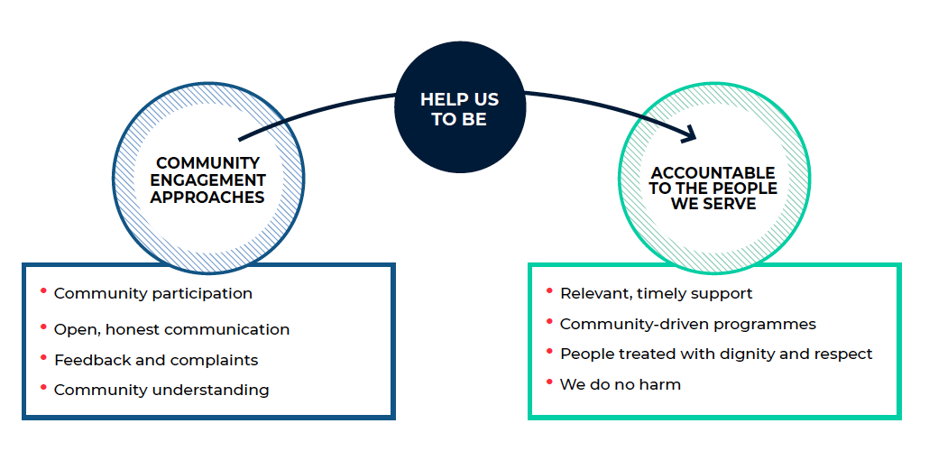
Within the Red Cross and Red Crescent Movement (the Movement) there are strong commitments to being accountable to communities in the International Red Cross and Red Crescent Movement’s Code of Conduct in Disaster Relief and the Principles and Rules for Red Cross and Red Crescent Humanitarian Assistance. In December 2019, the first set of ‘Movement-wide Commitments for Community Engagement and Accountability’ was approved at the Council of Delegates (see below).

Within the wider humanitarian sector, the Core Humanitarian Standard, Grand Bargain 2.0, and Interagency Standing Committee all support and encourage greater accountability to and engagement with communities.

CEA within the <insert name of National Society, office or delegation>
<insert name of National Society, office or delegation> has been working to strengthen CEA since <year>. This has included <outline what has been achieved so far in relation to CEA. For example, staff positions created, trainings delivered, CEA policies or strategies developed, CEA activities which have been integrated within programmes or operations e.g. feedback mechanisms>.

This has led to many benefits for the <insert name of National Society, office or delegation> including <list any positive outcomes the National Society, office or delegation has experienced as a result of CEA, such as improved understanding of communities, better quality programmes and operations, more community ownership of interventions, better trust and access to communities, improved reputation with donors and partners. Try to be specific and give concrete examples of how CEA has contributed to the National Society or office/delegation.>

Challenges still faced in adopting a stronger approach to CEA include <outline challenges or barriers faced in strengthening CEA in brief.>

CEA staff within <insert name of National Society, office or delegation>
The <insert name of National Society, office or delegation> has <insert details of CEA department, unit or staff position> whose role it is to <insert details of what the CEA position or department does and its core areas of focus and support>.

<Insert the contact details for CEA staff, including name, job title, area of responsibility (e.g., a specific region or area of CEA), email and telephone>.

CEA roles and responsibilities for different positions & departments
If the briefing is being given to new staff in person, you only need to go through the responsibilities relevant to the staff positions you are briefing.

Role | Responsibility
Leadership | Institutionalize community engagement and accountability approaches within your organization:  - Recruit staff to manage this work and allocate funding for it  - Task a working group to lead institutionalization, including developing a CEA policy and integration in strategies, plans, budgets, and proposals  - Make accountability one of the organization’s key performance indicators and discuss progress against these in meetings
Programmes and operations | Ensure your programme or operation engages communities well:  - Include community engagement activities in plans, budgets, and proposals, including mechanisms to share information, facilitate participation, and listen to and act on feedback  - Be flexible enough to respond to changes in needs and context  - Integrate community engagement sessions into trainings  - Monitor how well your programme or operation is meeting peoples’ needs and if they feel informed and engaged
CEA staff | Lead and support efforts to strengthen community engagement and accountability in your organization:  - Provide training and technical support to staff and volunteers at all levels  - Establish and manage a community feedback mechanism  - Develop community engagement and accountability policies and plans, including integration into other sector’s policies, tools, and trainings
PGI staff | Work with CEA, to support programmes and operations:  - Include questions on how to engage communities in gender and diversity analysis  - Ensure community engagement approaches are part of PGI work  - Mainstream PGI in community engagement approaches
Volunteers | Be the link between the community and the National Society:  - Engage communities during your work by sharing information, answering questions, and reporting any feedback to the branch  - Involve community members in planning and delivering activities
Volunteer management / branch managers | Ensure good engagement with volunteers and communities:  - Good community engagement in branch activities  - Meet regularly (e.g., monthly) with volunteers and listen to and act on their feedback about what is happening in the community  - Treat volunteers the way we expect them to treat the community, by keeping them informed and involved in plans and activities
Planning, monitoring, evaluation, and reporting (PMER) | Integrate community engagement and accountability into PMER:  - Flag when community engagement is missing in plans  - Include indicators to measure the quality of community engagement in monitoring plans and evaluations  - Include community feedback in monitoring and reporting  - Support previous learning to be used to inform new programmes
Support services | Ensure our processes and procedures support community engagement:  - Logistics should input to plans so we don’t make unrealistic promises to communities about what we can provide and when  - Finance, logistics and administration procedures should be flexible enough to allow for changes as community needs evolve  - Information management and IT can support with equipment, software, and data management for feedback mechanisms
Human resources | Integrate community engagement responsibilities into HR processes:  - Include community engagement in staff and volunteer inductions  - Integrate community engagement responsibilities and competencies into role descriptions and hiring processes  - Support investigations into serious complaints
National Society Development | Support institutionalization of community engagement:  - Include accountability to communities in organizational development processes and assessments  - Include in organizational strategies, mission statements and values
IFRC, ICRC and partner National Societies | Support National Societies to strengthen accountability in their work:  - Provide technical support and funding for community engagement and accountability  - Include indicators in programme and operation plans to monitor CEA  - Advocate to National Society leadership on the importance of accountability to communities  - Institutionalize community engagement and accountability in your own organization  - Coordinate with Movement partners so support to National Societies is also coordinated and complementary.

CEA tools and resources
The Red Cross Red Crescent Guide to Community Engagement and Accountability
The Red Cross Red Crescent Guide to CEA provides practical guidance and support to staff and volunteers across all sectors, including management, to integrate community engagement approaches in their work. It includes step-by-step guidance to meet the 18 minimum actions for good community engagement and accountability, case studies and links to tools and training packages.
The Guide has seven modules covering; an introduction to CEA, the Movement-wide commitments, steps to institutionalize CEA at the organizational level, how to integrate CEA in programmes and emergency operations, setting up community feedback mechanisms, and links between CEA and other closely related sectors, such as protection, gender and inclusion (PGI) and behaviour change and risk communication.

The CEA toolkit
The CEA toolkit accompanies the CEA guide and is hosted on the community hub (below). The toolkit includes templates, checklists, and detailed guidance, including an assessment tool, monitoring and evaluation tool, guidance and tools to set up feedback mechanisms and template CEA policies, strategies and workplans. These tools support staff and volunteers to put the CEA minimum actions into practice.

The Community Engagement Hub
The Community Engagement Hub is a free online platform, hosted by British Red Cross, that provides a ‘one stop shop’ for community engagement and accountability. The hub contains over 300 resources and includes training packages, an e-learning game, an interactive map, a chat forum as well as tools, guides, and case studies on a range of topics from feedback mechanisms to radio programmes. Funded by the UK Foreign, Commonwealth and Development Office, the Hub is available in English, French, Spanish, and Arabic. If you have any questions or suggestions about the hub, please contact Laurel Selby LSelby@redcross.org.uk

Resource outside the Red Cross Red Crescent Movement
- IASC Accountability and Inclusion Portal https://aap-inclusion-psea.alnap.org/resources-iasc
- ALNAP HELP Library - https://www.alnap.org/help-library
- CDAC Resource Library - http://www.cdacnetwork.org/

Movement-wide commitments for community engagement and accountability
The Movement-wide Minimum Commitments for Community Engagement and Accountability (CR/19/R1) were adopted at the Council of Delegates on 08 December 2019. These overarching, strategic commitments aim to ensure a consistent approach to how we engage with and are accountable to people and communities across the Movement. All members of the Movement, including every National Society, ICRC delegation and IFRC office, is responsible for meeting and upholding these commitments and they are relevant and applicable to all staff and volunteers throughout the Movement regardless of their role.

Commitment 1: All Movement components commit to integrating community engagement and accountability in their strategies, policies and procedures.
Commitment 2: All Movement components commit to regularly conducting an analysis of the contexts they work in to better understand and address the diversity of needs, vulnerabilities and capacities of the people and communities they seek to serve and assist.
Commitment 3: All Movement components commit to facilitating greater participation of local people and communities, including National Society volunteers, and helping them to apply their knowledge, skills and capacities to find appropriate and effective solutions to their problems.
Commitment 4: All Movement components commit to systematically listening to, responding to and acting on feedback from the people and communities we aim to serve.
Commitment 5: All Movement components commit to greater transparency in our communications and relationships with people and communities we aim to serve.
Commitment 6: All Movement components commit to strengthening knowledge, skills and competencies in community engagement and accountability at all levels, and systematically incorporating this learning into our work.
Commitment 7: All Movement components commit to coordinating their approaches to community engagement and accountability when working in the same context, including with relevant external partners, in order to increase coherence and consistency, avoid duplication and improve effectiveness and efficiency.

Minimum actions to integrate community engagement and accountability into programmes, operations, and organizations
The 18 minimum actions below explain how to put the Movement-wide Commitments for Community Engagement and Accountability above into practice in our work.

Institutionalization
- Strengthen community engagement and accountability understanding and capacity at all levels in the National Society
- Allocate resources, including funding and staff, to strengthen and institutionalize community engagement and accountability
- Integrate community engagement and accountability into all National Society strategies, values, plans, policies and tools so it becomes a standard way of working for all staff and volunteers
- Establish a community feedback mechanism for the National Society, with processes for managing sensitive complaints

Programmes
Needs assessment and context analysis
- Search for existing information about the community
- Involve the community in planning the assessment
- Brief or train volunteers on the purpose of the assessment and how to communicate clearly and honestly
- Take time to understand the context, people’s needs and capacities
- Include questions about how best to engage communities in needs assessments

Planning and design
- Community members and key stakeholders must be involved in planning the programme, including men, women, boys and girls and marginalized or at-risk groups
- Cross-check plans with the community and other stakeholders before implementing to make sure they match needs and expectations
- Include community engagement and accountability activities and indicators in programme plans and budget, outlining how information will be shared, community participation supported, and feedback managed

Implementation and monitoring
- Regularly share information about the programme with community members, using the best approaches to reach different groups
- Enable active community participation in managing and guiding the programme, including marginalized and at risk groups
- Collect, analyse and respond to community feedback, ensuring people know how they can ask questions, make suggestions or raise concerns about the programme
- Review and adjust programme activities and approaches regularly based on community feedback and monitoring data

Evaluation and learning
- Involve communities in planning the evaluation and discussing the findings
- Ask community members if they are satisfied with the programme, how it was delivered and what could be improved

Emergencies
These are the most important minimum actions, from the programme actions above, to focus on in emergency operations when there is less time, greater urgency and often more complexity:
- Community engagement is integrated across the response
- Understand community needs, capacities, and context
- Carry out the assessment with transparency and respect for the community
- Discuss response plans with communities and key stakeholders
- Discuss and agree selection criteria and distribution processes with communities
- Include community engagement and accountability activities and indicators in response plans and budgets
- Regularly share information about the response with the community
- Support community participation in making decisions about the response
- Listen to community feedback and use it to guide the response
- Include the community in the evaluation

For example, the Organizational Capacity Assessment and Certification process (OCAC), Branch Organizational Capacity Assessment (BOCA) and Preparedness for Effective Response (PER) processes.

